ParkWise: A Smart Parking Management Prototype Using YOLOv8 Vehicle Detection

Krishna Surya Chowdary
Dept. of Computer Science and Engineering
ICFAI University
Hyderabad, India bikkinakrishnasuryachowdary24@ifheindia.org

Abstract—Finding a free parking space in a busy Indian city such as Hyderabad can mean circling the same streets until something opens up. ParkWise is a B.Tech project that explores how an operator dashboard, a relational parking database and an off-the-shelf object detector can be combined to make that search easier to manage. The system pairs a React and Vite web interface with a FastAPI backend, SQLAlchemy models and a SQLite store. Vehicle detection uses pretrained Ultralytics YOLOv8 weights with OpenCV, and a detection changes the status of a parking space only when its centre falls inside a manually configured region of interest. On the project's COCO 2017 benchmark configuration, run on a CPU, YOLOv8m reached 51.96% mAP@0.5:0.95 at about 397 ms per image, while YOLOv8n reached 38.63% at about 52 ms. We also report a separate offline experiment with classical classifiers on 1,726 empty and occupied parking images, together with the limits of its single recorded run. Throughout, we keep what is implemented apart from what is still demonstration data, and we list what has to change before the prototype can be trusted with real traffic.
Keywords—smart parking, YOLOv8, vehicle detection, occupancy mapping, region of interest, FastAPI, React

Introduction
Parking is one of those problems that feels small until you are the one looking for a space. In busy commercial areas, drivers who cannot see where the free bays are tend to keep driving until one appears, which adds to traffic and wastes fuel [1]. Smart parking systems try to close this information gap with sensors, cameras or booking services, and the research on them is extensive [2].
ParkWise began as our attempt to build a working version of such a system with Hyderabad in mind. It is a web application that an operator uses to watch capacity, edit parking records, manage vehicles and reservations, and run a vehicle detector on images, videos or camera frames. A driver-facing space finder, which can create a reservation, sits alongside the operator views.
We want to be clear from the start about what this paper describes. ParkWise is a prototype. Some screens, such as the demand forecast and parts of the analytics page, are driven by seeded or static demo data, and several features that appear in the interface are only partly wired up. Instead of presenting the planned system as finished, we report the implementation as it stands in the audited code base and give each component its actual status.
Our main contributions are the following:
- An integrated dashboard prototype that connects a React front end to a FastAPI and SQLAlchemy back end with 19 persistent entities.
- A YOLOv8 inference path for uploaded images, sampled video frames and configured cameras, with a simple region-of-interest (ROI) rule that turns detections into parking-space status.
- A stored CPU comparison of three pretrained YOLOv8 variants that makes the trade-off between accuracy and speed visible.
- A candid status audit that separates verified behaviour from demo data and sets out the work needed before deployment.
Section II reviews related work. Section III describes the architecture, and Section IV covers the detection pipeline. Section V explains the supporting modules, Section VI presents the evaluation and Section VII discusses limitations. Section VIII outlines future work, and Section IX concludes.

Related Work
Lin et al. [2] survey the field and organise it around how parking information is collected, how systems are deployed and how the information reaches drivers. Sensors fitted to each bay give clean signals but need hardware in every space. A single camera can cover many bays at once, which is one reason vision-based occupancy detection keeps attracting attention.
Two broad vision approaches appear in the literature. The first classifies image patches of individual bays as empty or occupied. The PKLot dataset [3] made this easy to benchmark, and Amato et al. [4] showed that a compact convolutional network could run the classification on cameras with limited computing power. The second approach detects vehicles as objects and then reasons about where they are. Single-stage detectors from the YOLO family [5] are popular for this because they are fast, and the Ultralytics release of YOLOv8 [6] ships with weights pretrained on the 80 COCO categories [7], which include car, motorcycle, bus and truck.
ParkWise touches both ideas. Its live path uses an object detector followed by a rule that maps boxes to bays. Its offline experiment uses patch classification, though with classical models [8]–[10] in place of a CNN. We chose that mix on purpose, since a pretrained detector needed no labelled ParkWise footage to get started. Route guidance inside a car park is often framed as a shortest-path search, for which A* [11] is the standard heuristic method. We come back to this in Section V, because the current code does not yet implement it.

System Architecture
Fig. 1 shows the overall structure. Requests travel from the browser through FastAPI to SQLAlchemy and SQLite. The AI routes add a detection branch that can write slot status back into the same database.
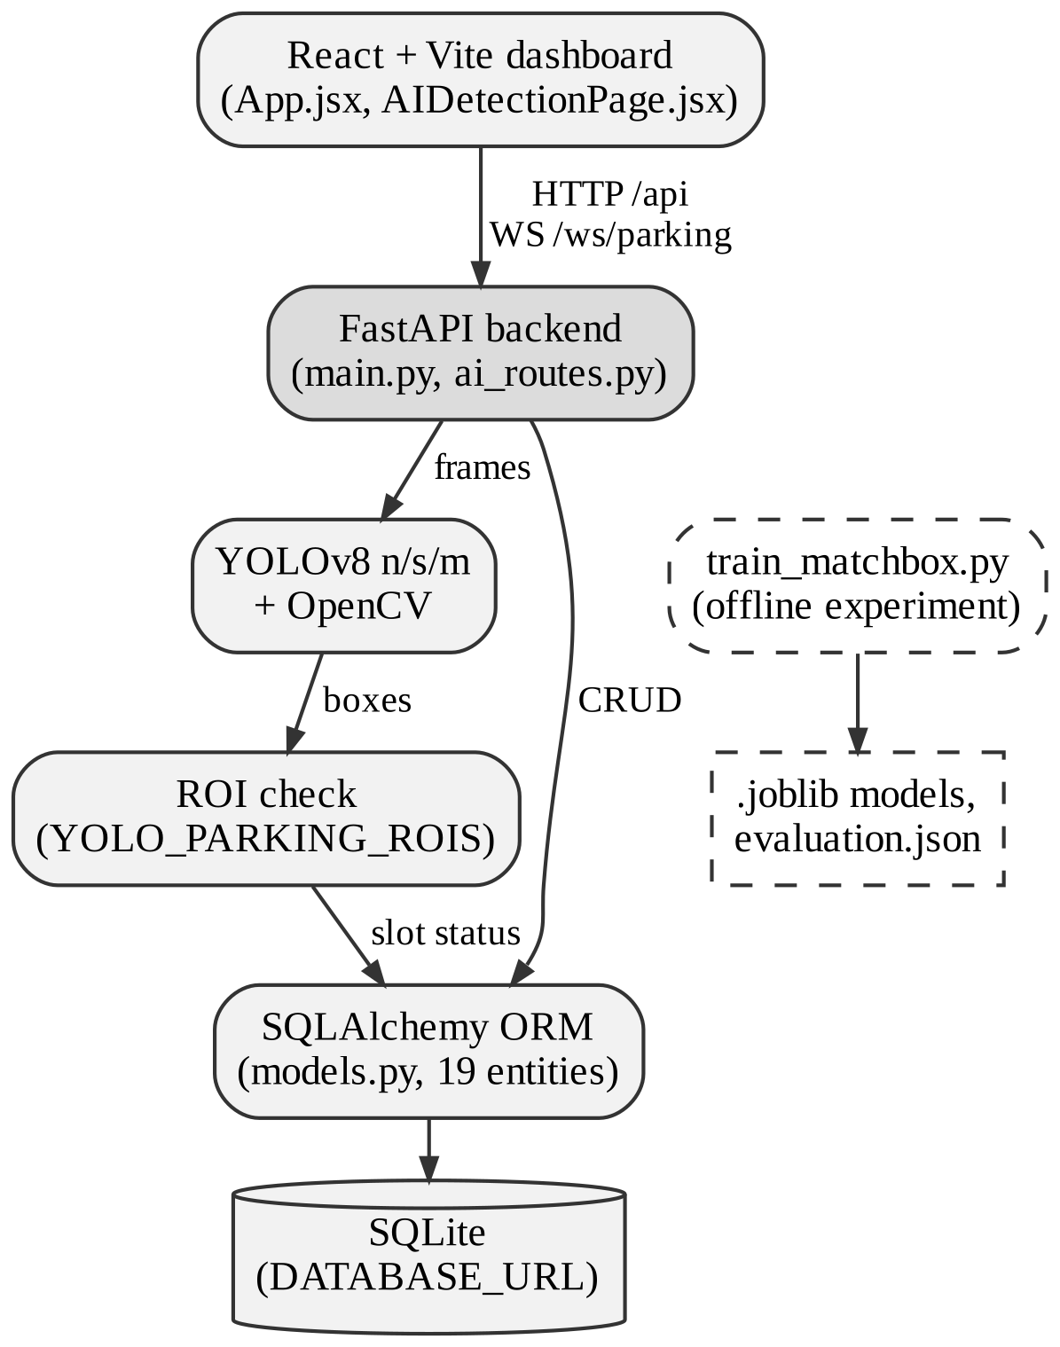
- ParkWise architecture. Dashed boxes mark the offline Matchbox classifier, which has no runtime link to live inference.

Front End
The client is a single-page application built with React 19, React Router 7 and Vite 8. Most pages live in src/App.jsx, while the vehicle-detection page has its own file, src/pages/AIDetectionPage.jsx. Charts are drawn with Recharts, icons come from Lucide and styling is plain CSS. We did not use a global state library. Each page holds its own state with React hooks and calls thin Axios wrappers grouped by domain under src/api/. The shared client in src/api/client.js converts timeouts, network failures and HTTP errors into readable messages, so a failed request shows up as an error and not as an empty table.
The navigation covers login, an overview dashboard, a space finder, a demand forecast, an AI and dataset page, vehicle detection, parking spaces, vehicles, reservations, analytics and settings. During development, Vite proxies /api and /ws to the backend. For deployment, the client reads VITE_API_URL and VITE_WS_URL instead.

Back End
The backend runs FastAPI [12] under Uvicorn, with Pydantic 2 models validating request bodies. Two modules carry the routes. The first, backend/app/main.py, builds the application, registers CORS, creates tables and seeds demo data on startup. It also holds the general endpoints for health, the dashboard summary, parking lots and spaces, recommendations, pricing, vehicles, reservations, payments, navigation, analytics, test records and authentication. The second, backend/app/ai_routes.py, is mounted under /api/ai/vehicle-detections and handles image, video and camera inference, detection history and model evaluation.
We put business logic such as pricing and recommendation directly inside main.py. That kept the prototype quick to build. It also makes the logic harder to test on its own, so we plan to move it into a separate service layer. Settings are read in backend/app/core/config.py, the engine and sessions are created in core/database.py, and core/security.py holds the password-hashing and token helpers.

Data Model
Our data model in backend/app/models.py declares 19 ORM entities, all with integer primary keys. The core relations are simple. A parking lot contains levels and spaces, a user owns vehicles and reservations, a vehicle can have reservations and parking sessions, and each session can carry one payment. Parking spaces also link to detection records and to an occupancy history table, which is how the vision path leaves a trace in the database. Other tables store YOLO evaluations (with metrics and confusion-matrix data as JSON), pricing rules, camera devices, system events, model comparisons and test-case results.
Each ParkingSpace row is identified by a unique space_code. It stores the lot and level, zone, status, type, accessibility and EV flags, an optional current vehicle and coordinates. The statuses used in seed data and in the interface are AVAILABLE, OCCUPIED, RESERVED and HELD. Tables are created with create_all() at startup. Alembic is configured, but no migration revisions have been written yet.

Vehicle Detection and Occupancy Mapping

Detector
We do not define our own network. ParkWise loads pretrained YOLOv8 checkpoints (yolov8n.pt, yolov8s.pt and yolov8m.pt) through the Ultralytics API, caches the loaded models and guards inference with locks. The predict call passes the class IDs for car, motorcycle, bus and truck, so other COCO objects never reach the response. Confidence threshold, IoU threshold, input size and device are not set explicitly. They therefore follow Ultralytics defaults and automatic device selection, and any speed or accuracy figure we report depends on those defaults.
Three server-side input paths share the same core. An uploaded image, limited to 100 MB, is decoded with OpenCV [13] and NumPy. An uploaded video is sampled, with at most 600 frames processed, and an annotated MP4 is written and served back through an endpoint that checks the file name and type. A camera listed in YOLO_CAMERA_SOURCES can be asked for a single frame on demand. The browser camera on the detection page adds a fourth source from the client side. Each response returns the detections, annotated previews, timing and an occupancy summary, and every detection is stored with its inference metadata.

From Boxes to Parking Spaces
A bounding box tells us where a vehicle is in the image, not which bay it is in. We bridge that gap with a deliberately simple rule. The setting YOLO_PARKING_ROIS maps each space_code to a normalized rectangle in the camera view. For a detection with corners (x₁, y₁) and (x₂, y₂), the centre is
c = ((x₁ + x₂) / 2, (y₁ + y₂) / 2) (1)
and the detection is assigned to a space whose rectangle [u₁, u₂] × [v₁, v₂] satisfies
u₁ ≤ c_{x} ≤ u₂ and v₁ ≤ c_{y} ≤ v₂ (2)
with the centre expressed in the same normalized coordinates as the rectangle. A space that receives a detection is marked occupied. When a frame has been processed and no detection falls inside an eligible space's rectangle, that space can be marked available. RESERVED and HELD states are left untouched, so a booking is never overwritten by what the camera happens to see. Each change is written to the occupancy history.
The rule has clear limits. If no ROI is configured, the detection is still logged but no space changes status. The rectangles belong to one fixed camera view, so moving or zooming the camera quietly breaks the mapping until someone recalibrates it. The centre test also has no special handling for a vehicle that straddles two bays or is heavily occluded by its neighbour.

Supporting Modules

Space Recommendation and Reservations
The space finder calls GET /api/parking/recommend, loads vehicles and spaces, and lets the user create a reservation through POST /api/reservations. Reservations support create, read, update and delete operations and are stored in the database. Our recommendation logic is basic, and we wrote it for demonstration. It does not lock a space while someone is booking it, and conflict prevention for simultaneous requests has not been built yet.

Occupancy-Tier Pricing
The endpoint GET /api/pricing/current returns an hourly rate chosen by determine_price_rate() from the current occupancy percentage. Table I lists the tiers. A value exactly on a boundary moves to the higher tier, so 40% occupancy already costs INR 30. Similar tiers are seeded into the pricing_rules table, but the helper ignores those rows and uses hard-coded values, so editing a rule in the database does not change the price. We therefore call this fixed tiered pricing, not dynamic pricing in any learned sense. Payment records can be created and listed, but no payment gateway is connected.
- Occupancy-Tier Hourly Rates
Current occupancy | Rate (INR/h)
Below 40% | 20
40% to below 70% | 30
70% to below 90% | 40
90% to 100% | 50
- Hard-coded in main.py; seeded pricing_rules rows are not read by the helper.

Route Search
POST /api/navigation/route returns a list of nodes between a start and a goal. The function behind it is named a_star(), but it uses a FIFO queue with no heuristic and no edge costs, which makes it a breadth-first search. On an unweighted graph a breadth-first search still finds a path with the fewest edges, so the output is usable. It is not A* [11], however, and some route details come from static fallback values. We have kept the A* label out of our claims for that reason.

Offline Matchbox Classifier
We also ran a separate experiment on 1,726 parking images with the script backend/train_matchbox.py. Of these, 908 are empty and 818 are occupied. Each image is reduced to a 32×32 RGB representation, and a 16-bin histogram per colour channel is added to the feature vector. A stratified 70/15/15 split feeds four classifiers: a decision tree, a random forest [8], a linear SVM and XGBoost [9], built with scikit-learn [10] and the XGBoost library. The fitted models, the scaler and an evaluation.json file are saved under data/matchbox_evaluation/.
None of these artifacts is loaded by the camera path. The classifier is an offline study and plays no part in live occupancy detection. Some interface text mentions a CNN, but no CNN has been implemented.

Analytics, Forecast and Live Updates
Our overview dashboard reads live totals and occupancy from the database. The demand forecast, on the other hand, comes from a 16-row CSV of sample hourly values, and parts of the occupancy and revenue analytics return static arrays. The forecast page labels its data as demo output. The monitoring page opens a WebSocket at /ws/parking, but the server currently echoes messages back without broadcasting space changes. In practice the interface stays current through periodic polling.

Evaluation

Datasets
We evaluate the detector on a COCO 2017 [7] validation bundle stored in data/coco_vehicle_benchmark/. It holds 5,000 JPEG images and 36,781 annotations across all 80 COCO categories. The four runtime classes account for 1,932 car, 371 motorcycle, 285 bus and 415 truck annotations. These are object counts, not image counts. The dataset YAML defines validation and test lists of 500 images each, and the two lists do not overlap. There is no ParkWise-specific camera dataset for the detector, which matters when reading the results below.
The Matchbox images are described in Section V-D. Their original source and collection process are not documented in the code base.

YOLOv8 Results
Table II and Fig. 2 report the stored evaluation of the three bundled checkpoints on a CPU. Precision P, recall R and mAP come from Ultralytics validation, and F1 is their harmonic mean:
F1 = 2PR / (P + R) (3)
- Stored CPU Evaluation of Pretrained YOLOv8 Checkpoints
Model | P | R | F1 | mAP 0.5 | mAP 0.5:0.95 | Time (ms) | FPS
YOLOv8n | 59.95 | 49.03 | 53.94 | 53.50 | 38.63 | 52.4 | 19.08
YOLOv8s | 67.62 | 55.67 | 61.07 | 62.05 | 45.60 | 154.6 | 6.47
YOLOv8m | 71.53 | 61.99 | 66.42 | 68.78 | 51.96 | 397.4 | 2.52
- P, R, F1 and mAP in %. COCO 2017 configuration with all 80 classes; values from the root parkwise.db snapshot, times rounded.
Going from the smallest to the largest bundled model, mAP@0.5:0.95 rises from 38.63% for YOLOv8n to 51.96% for YOLOv8m, a gain of about 13.3 points. Inference time, though, climbs from about 52 ms to about 397 ms per image, so the larger model is roughly 7.6 times slower. In frame-rate terms that is 19.1 FPS against 2.5 FPS. Our project picks the model with the highest mAP@0.5:0.95, which is YOLOv8m. Is that the right default? For a parking camera that only needs a fresh reading every few seconds, that choice is reasonable. For anything close to real-time video on a CPU, YOLOv8n is the practical option. No YOLOv8l result is reported because no large checkpoint is bundled.
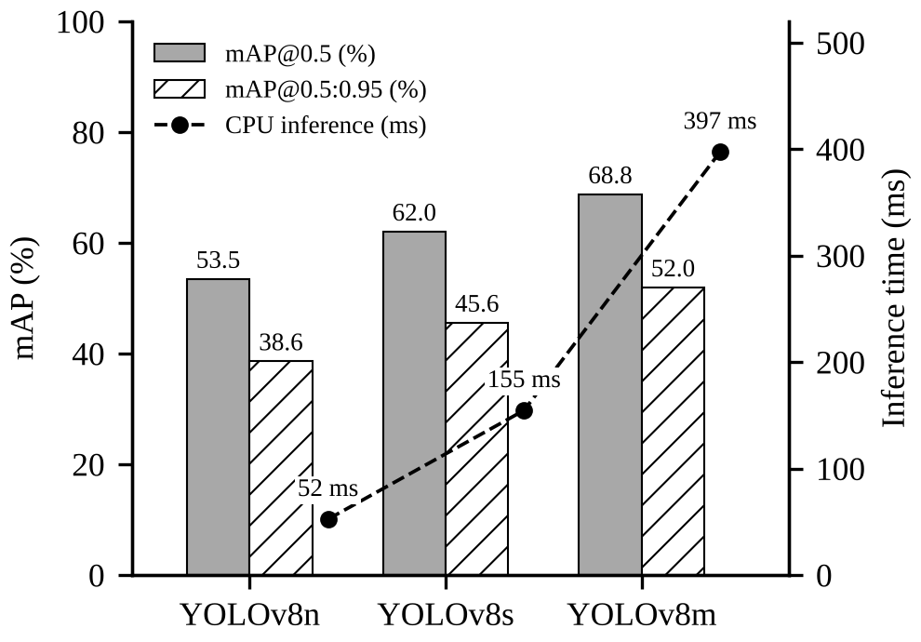
- Stored CPU evaluation of the bundled YOLOv8 checkpoints. Bars show mAP (left axis); the dashed line shows mean inference time per image (right axis).
Two caveats apply. First, the COCO configuration evaluates all 80 categories, while live inference keeps only four vehicle classes, so these figures describe general detection quality and not vehicle-only accuracy in a car park. Second, the numbers depend on the CPU, library versions and default settings used, and we have not repeated the run on other hardware. We do not report accuracy for the detector, since it is not a meaningful measure for bounding-box detection.

Matchbox Classifier Results
The file evaluation.json records one run on a 259-image test split, summarised in Table III. The random forest scored 100% and XGBoost 99.23%, followed by the decision tree at 94.98% and the linear SVM at 83.78%.
- Recorded Matchbox Classifier Test Accuracy
Classifier | Accuracy (%)
Random forest | 100.00
XGBoost | 99.23
Decision tree | 94.98
Linear SVM | 83.78
- Single stored run on 259 test images; not independently reproduced.
We read these numbers with caution. They come from a single split that we have not reproduced, and no footage from a real ParkWise site was tested. A perfect score on 259 small images says more about how separable this particular set is than about how a model would cope with shadows, rain or a new camera angle. Checking the split for near-duplicate images would be a sensible first step before relying on it.

Software Checks
We have one backend test module so far, backend/tests/test_ai_routes.py, with three tests. In the latest recorded run two passed and one failed. The failure is a stale call: the test passes two arguments to the _detection_metrics helper, which now also expects model_names and target_counts. Frontend lint and the production build passed, with a warning about a large JavaScript chunk, and the backend compiled without syntax errors. There is no frontend unit-test suite, and no field measurements of occupancy accuracy or deployment throughput exist yet.

Implementation Status and Limitations
Table IV summarises each component using the status labels from our code audit. Beyond the individual gaps, a few issues cut across the whole system.
- Implementation Status of ParkWise Components
Component | Status
Dashboard, inventory, vehicles, reservations | Implemented, unverified
YOLO image and video inference | Implemented, unverified
YOLO evaluation and comparison | Implemented and verified
Browser and configured cameras | Partial
Detection-to-space ROI mapping | Partial
Login, password hashing, JWT | Partial
WebSocket live updates | Partial (echo only)
Route search labelled A* | Partial (breadth-first)
Matchbox classifier | Offline experiment
Occupancy-tier pricing | Demo (fixed tiers)
Demand forecast, analytics | Demo data
Payment ledger | Demo (no gateway)
CNN, OCR/ANPR, Dijkstra, RL | Not implemented
Database migrations | Not implemented
Production deployment | Unknown
- Labels follow the code audit; the Matchbox entry is implemented as an offline script only.
Split database. The default database URL is the relative path sqlite:///./parkwise.db, so the file in use depends on where Uvicorn is started. Two different populated files exist. The root copy holds 20 spaces, 5 vehicles, 3 reservations and the 3 YOLO evaluation rows, while backend/parkwise.db holds 20 spaces, 5 vehicles, 11 reservations, 7 test cases and no evaluation rows. The dashboard can therefore show different data depending on the launch directory, and this is the first thing we plan to fix.
Authentication. Login, registration, password hashing and token creation exist. Most API routes, however, do not require a validated bearer token, the Axios client does not send one, and the frontend route guard only checks whether a token marker is present in localStorage. The backend also falls back to a development SECRET_KEY if none is supplied. At present, authentication is a convenience in the interface and not an access-control boundary.
Dataset hygiene. The COCO YAML points its training path at the full val2017 directory, which also contains the validation and test lists. Because the weights are pretrained and the project runs no training, the stored results are not affected. Anyone who fine-tunes with this YAML as it stands, though, would leak evaluation images into training.
Calibration and demo data. ROI rectangles are placed by hand, and there is no automatic bay segmentation or camera calibration. Several analytics views look operational while showing seeded values, so users of the dashboard need to be told which numbers come from live records.

Future Work
Our roadmap is ordered by what currently blocks trustworthy results. First, we will set one absolute DATABASE_URL for every launch mode, repair the stale test and add route and schema tests for uploads, ROI updates and malformed input. Next comes real authentication: refusing the development secret in production, validating bearer tokens on protected routes and enforcing ownership by user and role. An initial Alembic revision will then replace create_all(), so the schema can change safely.
On the vision side, we plan to build disjoint training, validation and test splits before any fine-tuning and to evaluate on vehicle classes only, ideally with footage from a real Hyderabad car park. Per-camera ROI settings need validation and tests for every status transition, and camera errors should be visible to the operator. The Matchbox classifier will either be integrated as a second occupancy path with proper validation, or clearly labelled as offline research.
Later work covers the remaining demo features. Analytics should be computed from timestamped records, and a forecast model should only be trained once real history exists. Route search should move to a weighted graph with a correct A* or Dijkstra implementation, pricing should read its rules from the database, and the WebSocket should broadcast space changes. A reproducible deployment with HTTPS, restricted CORS, backups and load testing would come last.

Conclusion
ParkWise shows that a small student team can connect a modern web stack, a relational data model and a pretrained YOLOv8 detector into one working prototype. Its strongest parts today are database-backed record management and the detection pipeline, which handles images, videos and camera frames. The stored CPU comparison shows that YOLOv8m gains about 13 points of mAP@0.5:0.95 over YOLOv8n at roughly 7.6 times the latency. Detections do update parking-space status, but only through hand-placed regions of interest.
Forecasting, much of the analytics, rule-driven pricing, route planning and live push updates are still at the demonstration stage. The split database, weak API authorization and missing migrations also need attention before any real deployment. We think drawing that line honestly is more useful than claiming a finished smart parking system, and it gives us a clear order for the next round of work.

Acknowledgment
The authors thank [project guide name], Department of Computer Science and Engineering, [College Name], Hyderabad, for guidance and feedback throughout this project.

References
- D. C. Shoup, “Cruising for parking,” Transport Policy, vol. 13, no. 6, pp. 479–486, Nov. 2006.
- T. Lin, H. Rivano, and F. Le Mouël, “A survey of smart parking solutions,” IEEE Trans. Intell. Transp. Syst., vol. 18, no. 12, pp. 3229–3253, Dec. 2017.
- P. R. L. de Almeida, L. S. Oliveira, A. S. Britto Jr., E. J. Silva Jr., and A. L. Koerich, “PKLot: A robust dataset for parking lot classification,” Expert Syst. Appl., vol. 42, no. 11, pp. 4937–4949, 2015.
- G. Amato, F. Carrara, F. Falchi, C. Gennaro, C. Meghini, and C. Vairo, “Deep learning for decentralized parking lot occupancy detection,” Expert Syst. Appl., vol. 72, pp. 327–334, 2017.
- J. Redmon, S. Divvala, R. Girshick, and A. Farhadi, “You only look once: Unified, real-time object detection,” in Proc. IEEE Conf. Comput. Vis. Pattern Recognit. (CVPR), 2016, pp. 779–788.
- G. Jocher, A. Chaurasia, and J. Qiu, “Ultralytics YOLOv8,” 2023. [Online]. Available: https://github.com/ultralytics/ultralytics
- T.-Y. Lin et al., “Microsoft COCO: Common objects in context,” in Proc. Eur. Conf. Comput. Vis. (ECCV), 2014, pp. 740–755.
- L. Breiman, “Random forests,” Mach. Learn., vol. 45, no. 1, pp. 5–32, 2001.
- T. Chen and C. Guestrin, “XGBoost: A scalable tree boosting system,” in Proc. 22nd ACM SIGKDD Int. Conf. Knowl. Discov. Data Min., 2016, pp. 785–794.
- F. Pedregosa et al., “Scikit-learn: Machine learning in Python,” J. Mach. Learn. Res., vol. 12, pp. 2825–2830, 2011.
- P. E. Hart, N. J. Nilsson, and B. Raphael, “A formal basis for the heuristic determination of minimum cost paths,” IEEE Trans. Syst. Sci. Cybern., vol. 4, no. 2, pp. 100–107, Jul. 1968.
- S. Ramírez, “FastAPI,” software documentation. [Online]. Available: https://fastapi.tiangolo.com
- G. Bradski, “The OpenCV library,” Dr. Dobb’s J. Softw. Tools, vol. 25, no. 11, pp. 120–125, 2000.

